ORD Lesson 5: Developing and Annotating a Vertical Alignment in ORD

Learning Objective: This lesson is intended to teach how to create and annotate rail and road centerline vertical alignments.
Task 1: Importing a Terrain Model (Existing Ground Profile)
In this task we import a terrain model which provides a “terrain” or vertical geometry to our project location based upon collected survey data.
- Open the Lesson5.dgn file you created and annotated your horizontal alignment in from the last lesson.
- From the OpenRoads Modeling workflow, select the Terrain Tab and select the From File Tool under the Create Ribbon Group.
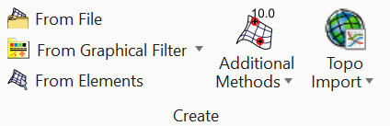

- A window will open requesting you to select a file to import. Download and select the “RUFF-BROS2.TIN” file provided.
- Once selected, the window below will appear. Set the settings to those shown in the figure and select Import.

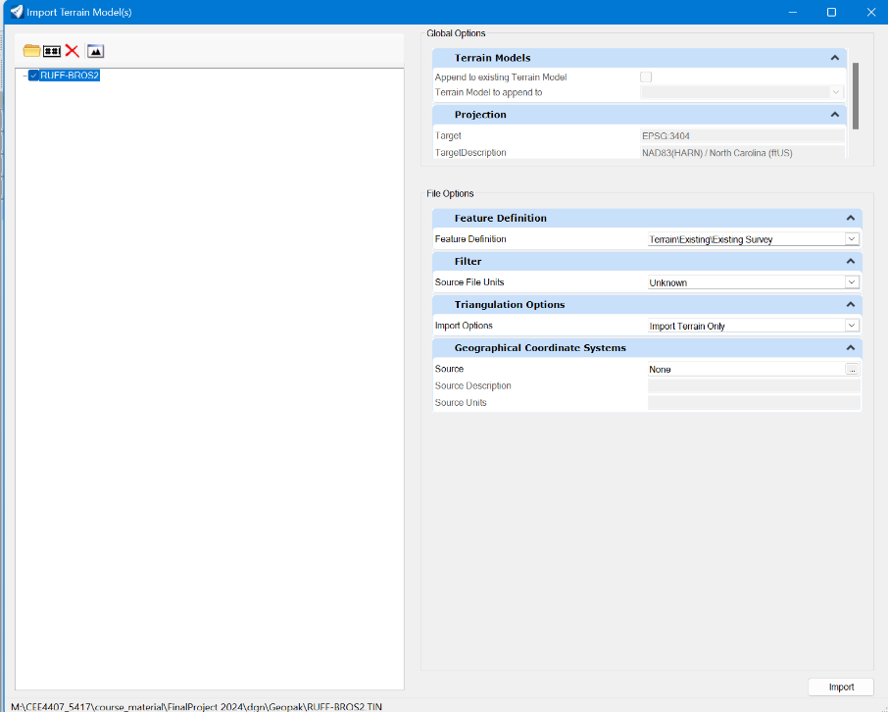

- Once imported, you can close the Import Terrain Models window. You have now imported the existing topography of the site into your OpenRoads file.
- Next, we will set our imported terrain model to our “Active Terrain”. To do this complete the following steps.
  - From the Home tab, select the Explorer Tool found under the Primary Ribbon group.
  - Select the “OpenRoads Model” fly down and expand the Lesson5.dgn, expand Terrain Models dropdown, and then right click on the “RUFF-BROS2” terrain and click “Set as Active”, as shown in the following figure.
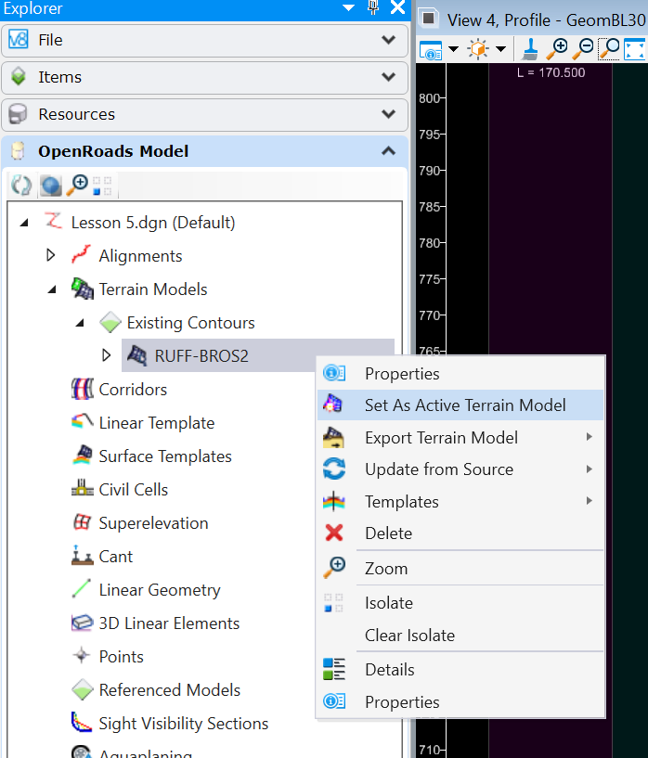

Task 2: Creating an Existing Vertical Profile
In this task we will create an existing ground profile along our proposed roadway.
- Within the OpenRoads Modeling workflow and Geometry tab, select the Open Profile Model tool from within the Vertical Ribbon group.
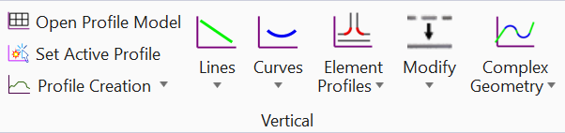

- You will be prompted on the screen to “Locate Plan Element”. Select your horizontal alignment for your proposed roadway.

- You will then be asked to “Select or Open View”. From the bottom of the screen select view #4 as shown in the figure on the next page and then click within the view to place the profile.
Select View 4 to Place Profile
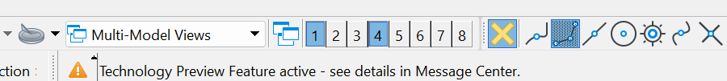

- You should now see a green dashed line on a profile grid. This line represents the elevation (or profile) of the existing ground along the length of your roadway.
Note:

Areas shaded in gray are areas in which you have placed a circular horizontal curve whereas areas shaded in purple are areas in which you have placed a spiral. Areas in black are areas of tangent/straight roadway. This aids in coordination of horizontal and vertical geometry.

Task 3: Creating Proposed Road Vertical Tangents
In this task we will use AASHTO guidelines to create a proposed vertical alignment for our proposed roadway.
- If it is not already set, be sure to set your active feature definition to “Geom_Baseline”.
- From within the profile view you created in Task 2, use the Element Selection Tool to select the existing ground profile (this is the green dashed line).
- With the existing ground profile selected, hover your cursor over the line, and select “Set as Active Profile” from the icons that appear on your screen (shown below).
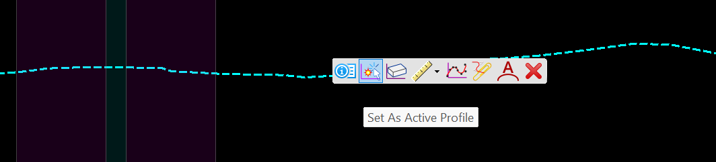

- From within the General Tools Ribbon group, click the Civil Toggles Tool and select Civil Accudraw from the drop-down list. The Civil Accudraw toolbar should appear as shown below. You can drag and drop this to pin/dock it within the top ribbon of your screen.
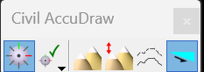

- Within the Civil Accudraw tool bar select the “Z” icon. This allows you to place new points on your profile based upon its “Z” value (vertical elevation).

- We will now begin placing our new (proposed) vertical profile for the proposed road. To do so the following parameters have been provided:
  - The profile should match the existing ground elevation at STA 50+00 and at the end of the alignment.
  - There are no minimum number of curves/VPI’s needed, however, follow the existing ground relatively closely (trying to balance cut and fill sections). You also do not want lots of VPIs either.
  - Make sure the approach grade coming into the intersection meets AASHTO standards.
- From the Geometry tab, within the Vertical Ribbon group, select the Lines Tool and then Profile Lines Between Points.
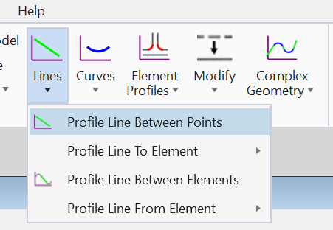

- You will then be prompted to enter a start location for the profile line on your screen. Enter the starting station of our alignment (50+00) starting at the elevation of the existing roadway (734.00’)
- With the starting point placed, you can then drag your cursor, and a dash orange line will emanate from the start point indicating the slope and length.
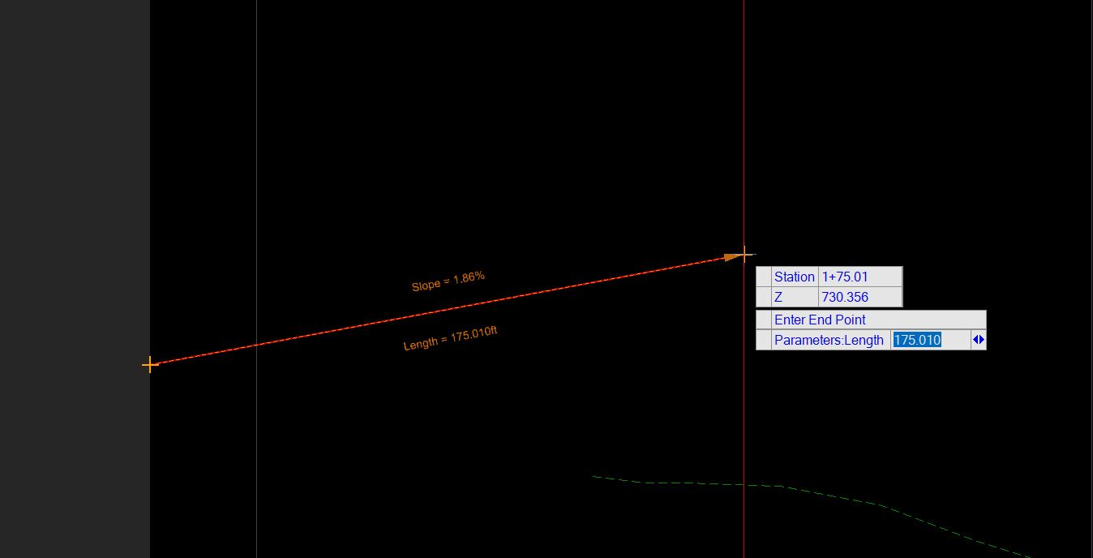

- Continue drawing lines to finish the profile. Below is an example profile, however there are infinite right answers.
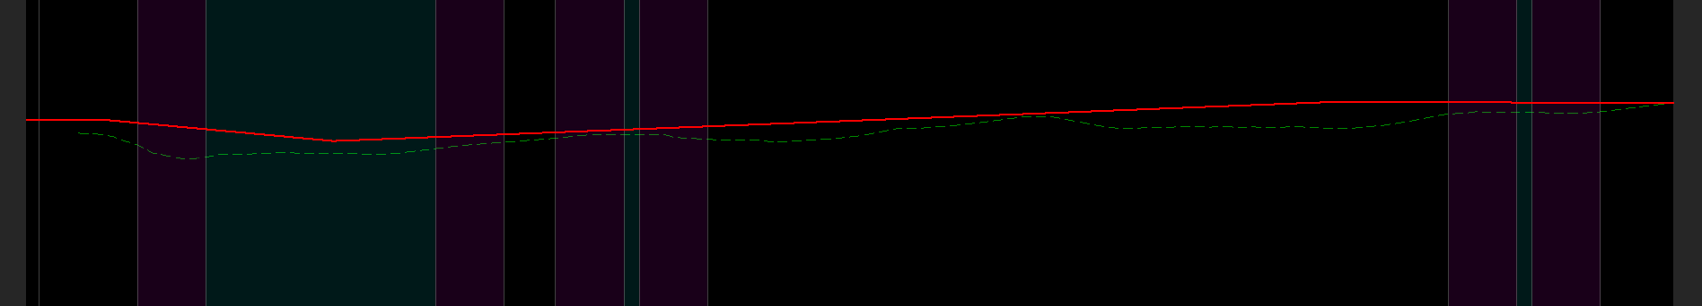

Task 4: Creating Proposed Road Vertical Curves
In this task we will create vertical curves using K values for our road alignment.
- While in the profile view for your proposed industry lead track, from the Geometry tab and Vertical Ribbon group select the Parabola Between Elements tool as shown below:
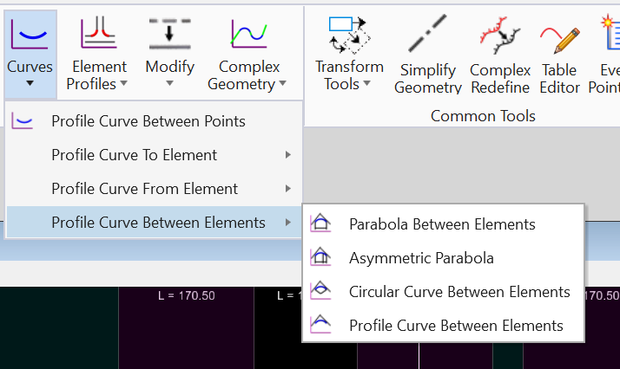

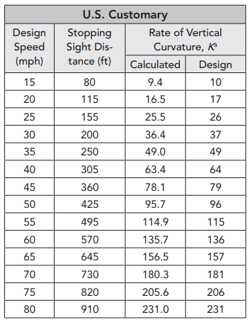
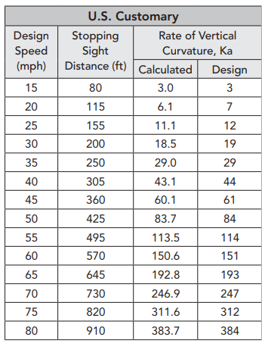
- In the Parabola Between Curves dialog box select the checkbox next to length and enter appropriate K value from the tables below for a 45mph roadway in the section of the dialog box labeled “Vertical Curve Parameter”. Once entered, select both tangents making up the proposed vertical curve and select to trim/extend “both”.

Table 3-37: Design Controls for Sag Curves Based on Stopping Sight Distance (AASHTO Green Book 2018)
Table 3-35: Design Controls for Crest Curves Based on Stopping Sight Distance (AASHTO Green Book 2018)

- Repeat the process described in steps 3 and 4 for the remaining curves on your vertical alignment.
- With your alignment complete, select the Complex Geometry Tool from the Vertical ribbon group (I.E not the horizontal ribbon group).
- Select the elements of the vertical profile making sure the arrow is pointing to the right as you do so.
- Congratulations! You just completed your first proposed vertical profile. Once complete you should have a complete vertical alignment for your roadway as shown below.

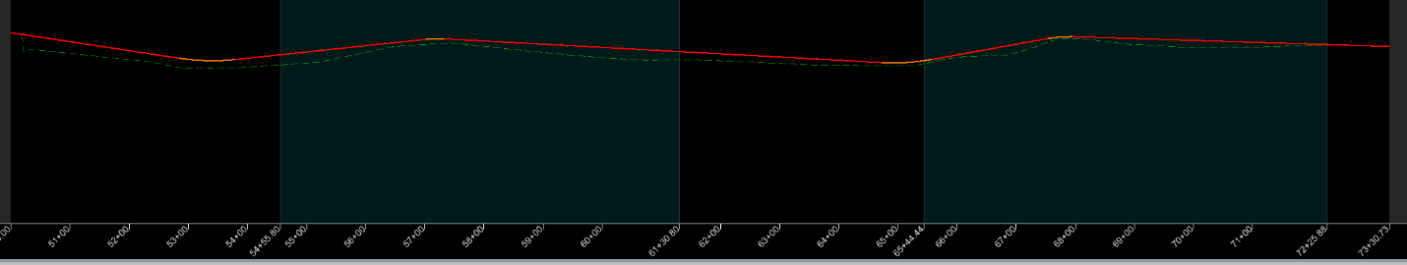

Task 5: Annotating the Vertical Profile and Creating Profile Sheets
- Change the workflow to OpenRoads Drawing Production and select the Element Annotation Tool from within the Drawing Production tab.
- Select your profile and then right-click to accept. Your profile will now be annotated with labels for the vertical profile.
- We will now create named boundaries to create sheets. To do so, select the Named Boundaries Tool from within the Drawing Production tab.
- With the named dialog box opened, select the settings shown below.
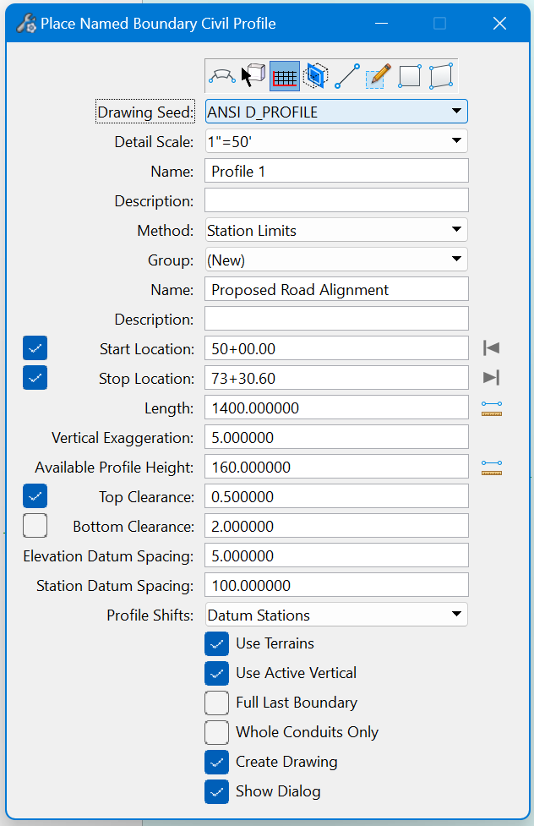
Be sure to select the profile icon at the top first
You can select this icon to automatically set the “Stop Location” to the end of the alignment.

- Once the dialog box is complete, click on the screen multiple times to accept the information entered. You will see the named boundaries appear on your profile and the Create Drawing dialog box will appear. Make sure the information matches that shown below and then click “OK”.
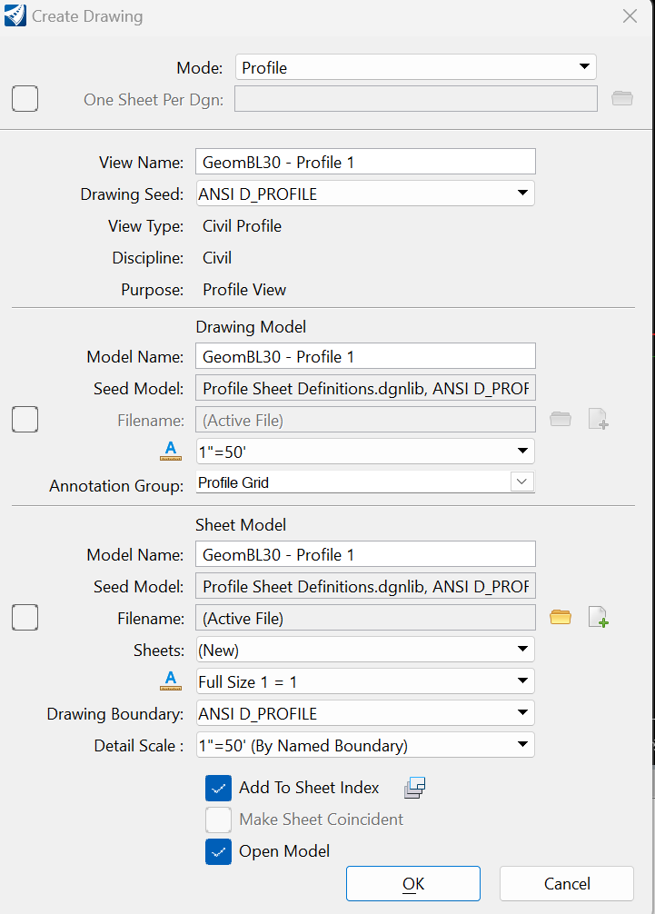

- Congratulations, your profile sheets should now be created!

Task 6: Printing Profile Sheets
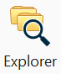
- From the Home tab, select the Explorer Tool.
- From the Explorer tool, select the drop down for “Sheet Index” and then select the Training Imperial sheet index as shown below:
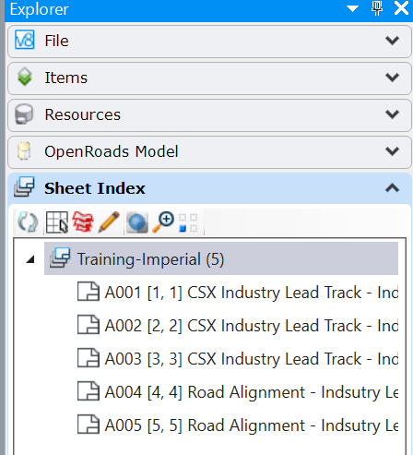

Print Organizer for Step 3

- Hold control and click on the profile sheets from within your sheet index and then select the Print Organizer Icon at the top (shown above).
- In the Select Print Style dialog box, select PDF and then click “OK”.
- In the Printer Organizer dialog box select the Print Button at the top (shown below).
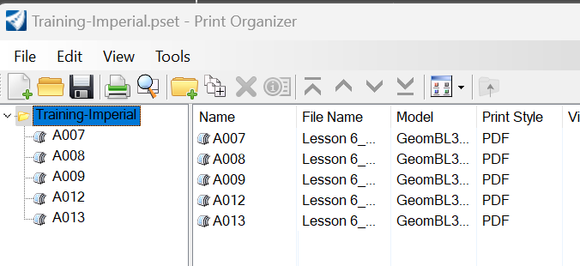

- In the print dialog box make sure the settings are the same as the image below making sure the destination is set to the folder of your preference. Once correct, select “OK”.
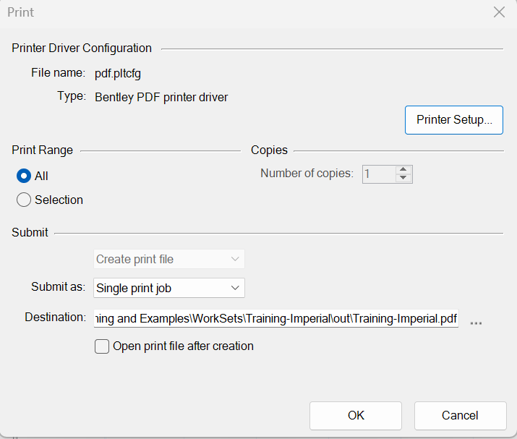

- A single pdf file of your profile sheets is created. Submit this file and your dgn file.

