ORD Lesson 6: Using Horizontal Alignments, Vertical Profiles, and Corridors to Create a Detailed Cross-Section

Learning Objective: This lesson will show you how to utilize the horizonal alignment and vertical profile for a road we created in previous lessons. To create a cross-section, first you must create a corridor, a dynamic 3D model of the road. The horizontal alignment and vertical profile created in the previous lessons will be necessary to create the corridor.
Task 1: Creating a Corridor

- Open ORD and create a new file. Name it Lesson6_corridor.
- To create a corridor, we must reference the necessary files. Go to the Home tab, Attach Tools dropdown, and References. Using the “Attach References” icon (shown to the right), import the following files.
  - Survey file: “survey2d”
  - File with the alignment and profile: “Lesson5.dgn”
- We also must import our terrain file. To do that, go to the Terrain tab, and select the From File Tool. In the window that appears, select the following file and click Import in the following window.
  - Terrain File: “RUFF-BROS2.TIN”
- We need to make sure it’s set as the active terrain. To do this, go to the Home tab, open the Explorer, find OpenRoads Model, and find “RUFF-BROS2” under the Terrain Models. Right click on the terrain and set as active terrain, as shown below.
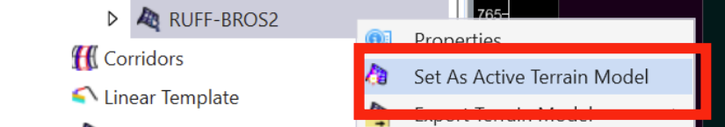

- Now the file is ready to create a corridor. Find your horizontal alignment, click and hover, and select the Create Corridor Icon.
Create Corridor
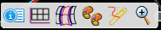

Open Profile Model

- Follow the prompts of the command in the corresponding window.
  - Locate Profile: Select the profile created in Lesson 5.

Note: Profile may not appear automatically. You may need to right-click on your alignment and select Open Profile Model in a new view. (Shown above)

  - Corridor Name: Name the corridor “Corridor1”.
  - Select Template: Press Alt and Down Arrow simultaneously to bring up the template options. Choose “2 Lanes” (Components 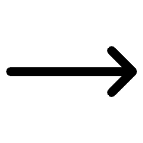 Pavement New Asphalt Undivided 2 Lanes).
  - Start Station: Find and click on the starting station of the profile. Or manually type the starting station in the corresponding text box. Press enter or check the checkbox to lock in that station.
  - End Station: Find and click on the ending station of the profile. Or manually type the ending station in the corresponding text box. Press enter or check the checkbox to lock in that station.
  - Interval: Enter the desired drop interval. This will be the maximum distance between stations in which cross-sections could be taken. For this corridor, the drop interval should be 10.
- The completed window should resemble the following image.
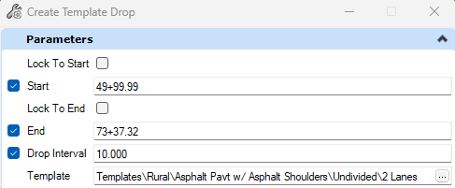

- Right click in the view window to activate the corridor. The result should match the following image. To view the corridor in 3-D, click on the drop-down in the bottom left of the screen, and change the view to Default-3D Views.

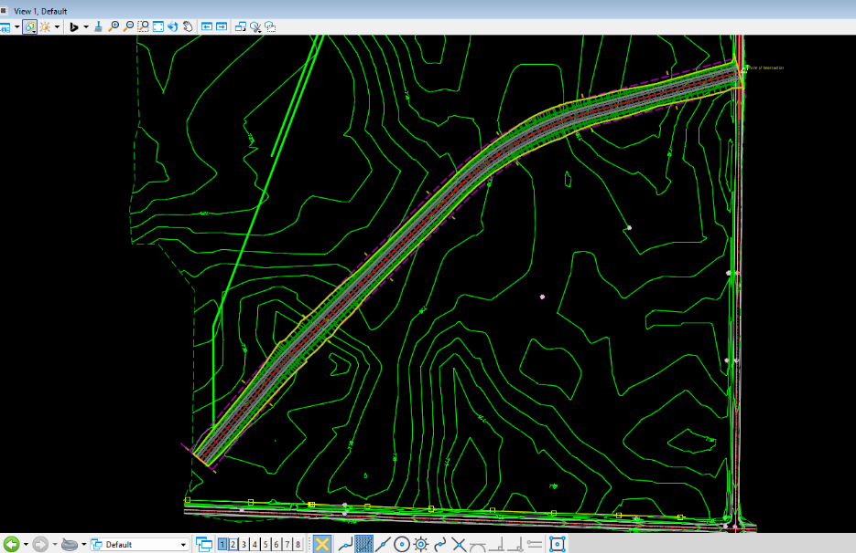

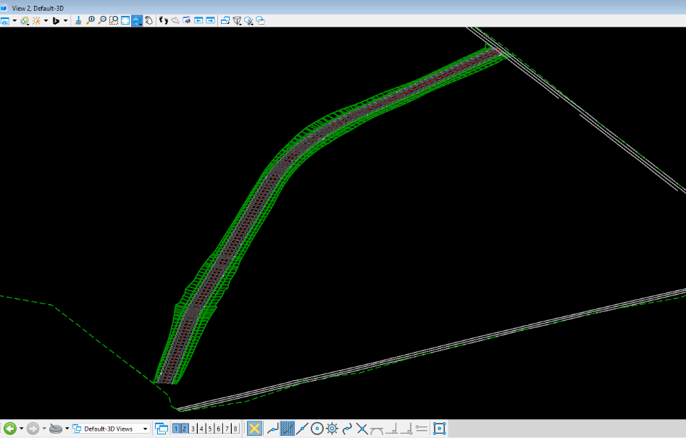

Task 2: Creating Cross Sections
- Reopen ORD and create a new file. Name it Lesson6_crosssection.
- Repeat the steps in Task 1, Step 2 to reference the necessary files to create a cross-section. In addition, reference the file created in Task 1 with the corridor- “Lesson6_corridor”.
- Also repeat Task 1, Steps 3 & 4, to import the terrain and set as active terrain.
- In the Drawing Production tab, under Named Boundaries, select Place Named Boundary.
- Select your alignment, then within the dialog box, complete the following steps.
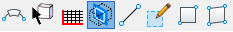
  - Ensure Civil Cross Section Icon is selected.

  - Select the Drawing Seed ANSI D_XS. This will automatically set most settings within the dialog box and they shouldn’t be modified.
What is a Drawing Seed?

A Drawing Seed is a template that controls how the named boundary will look. It’s a predefined set of settings and standards that directly corresponds to the scale of the cross-section you will be creating.

  - Check that the group dropdown is set to “New”.
  - Name your cross-section group “Group1”.
  - Find and click on the starting station of the profile. Or manually type the starting station in the corresponding text box. Press enter or check the checkbox to lock in that station.
  - Follow the alignment with your cursor and click on the ending station of the profile. Or manually type the ending station in the corresponding text box. Press enter or check the checkbox to lock in that station.
  - Make certain the Event Point List is set to “None”, and Named Group is set to “None”.
  - The following should be left unchecked- Include Control Points, Backward Facing, & Create Drawing.

- The completed dialog box should match the following.
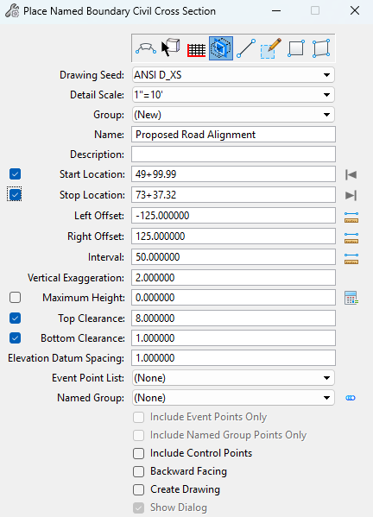

- Double click in the view to activate the cross sections you just created. You should see lines at each set interval, perpendicular to the alignment, shown in the following image.
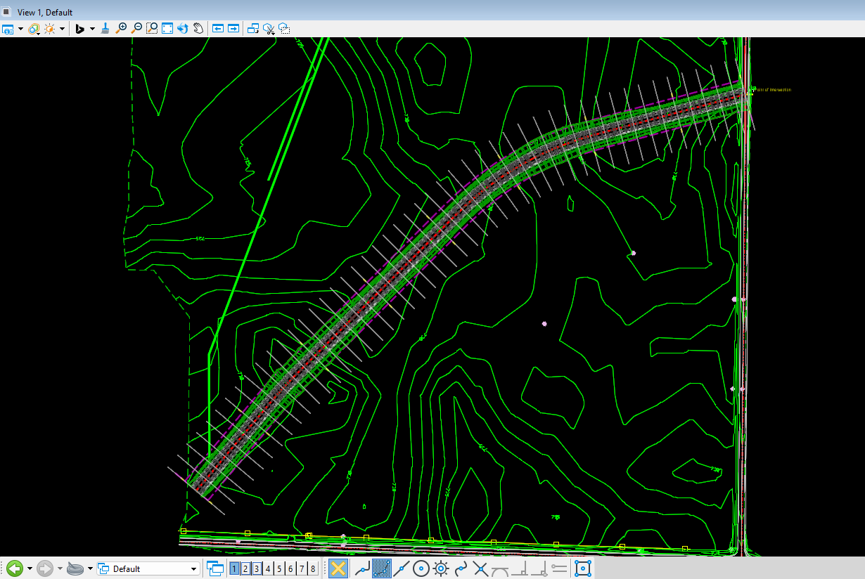
- The Cross Section should also be viewed in the 3-D view, similarly to the corridor.
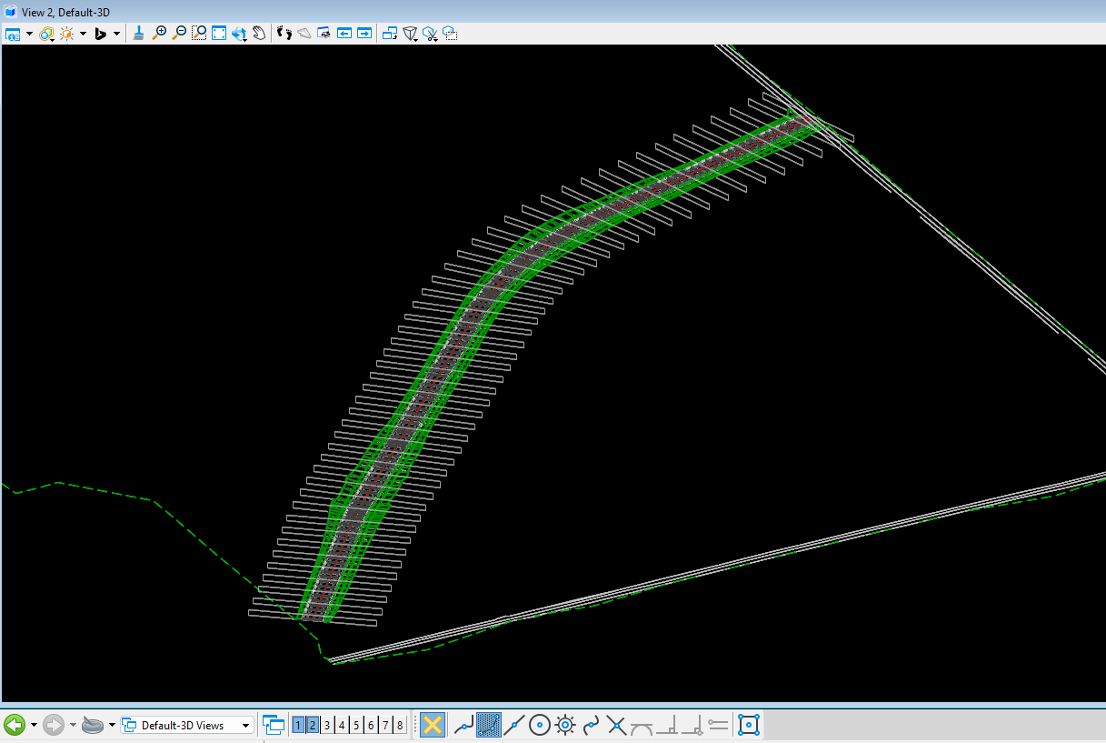

Task 3: Viewing Cross Sections
- Back in the 2-D view, select the Cross Section Navigator, in the Drawing Production tab, under Review.
- Following the prompts of the tool, select your alignment, and open the cross section navigator in a different view.
Cross Section Navigator

The Cross Section Navigator allows us to view the cross section at each station without having to create a drawing sheet for each one. You should see the road cross sections with annotations, as well as daylights, or ditches connecting the road to the existing elevation at that station. Use the arrows in the tool bar to shuffle through the stations, watching how the terrain changes as you move along.

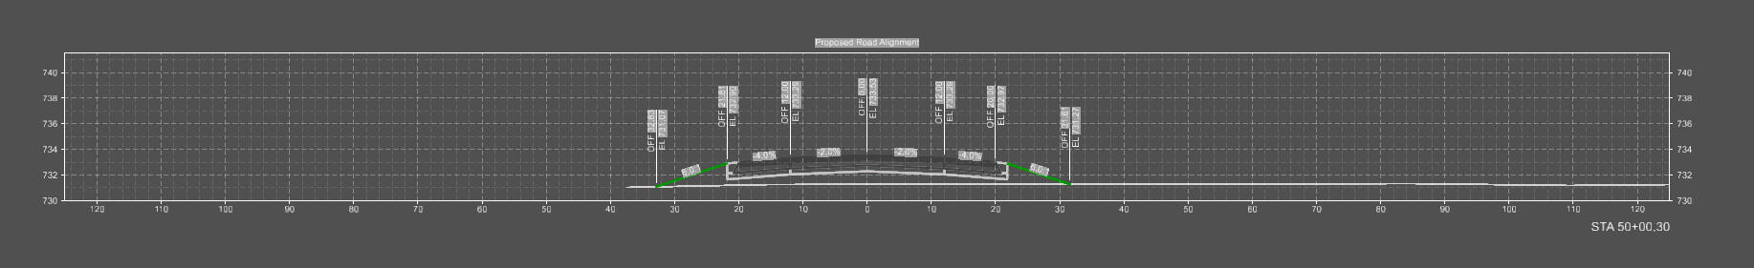
- For this assignment, view the cross section at 50+00.00, similarly to the one below.

- Save this as a dgn file and submit.

